Enhancing Professional Networking with Proximity Detection via Bluetooth Beacons
Aria Barve & Deen Kareem
Mentor: Dr. Alvin Chin, Discovery Partners Institute

Many participants attending professional events such as conferences or ​conventions seek to network. By understanding the relationship between physical proximity and successful network connections, we can enhance the networking experience. This study examines the use of Bluetooth signals to determine when a physical encounter occurs and suggest a potential professional connection. By analyzing RSSI data from an Android app, encounters between individuals are logged to determine if predicting physical proximity is feasible. Although this shows potential, there are improvements to be made. Future research will analyze audio data to determine the difference between true interactions and physical proximity and continue improving the encounter algorithm.

Introduction

Online social networking is essential for professional development however there are several issues with the current state of the networking process. It heavily relies on 1) chance encounters in passing, or during pre-scheduled meetings 2) remembering the person you met and 3) remembering to connect with this person on a social networking platform. Introducing a contact tracing platform at large conferences and events could address these drawbacks of traditional networking. Several methods are often used to obtain proximity data when contact tracing. Studies such as that by Barnett et al. (2024), aim to use Bluetooth Low Energy (BLE) Beacons in conjunction with a mobile application to detect the presence of said beacons. Other studies such as Catarinucci et al. (2011) aim to use RFID technology to develop a context-aware network that can detect another individual's presence. This study aims to utilize smartphones' Bluetooth capabilities to detect surrounding devices that represent other users. This approach avoids the need to distribute RFID or BLE infrastructure and instead utilizes the Bluetooth capabilities from smartphones that users already have. To do this, each phone participating in the study emits a Bluetooth UUID, and then the other devices collect this and record the Received Signal Strength Indicator (RSSI) to infer the proximity. There are several benefits to utilizing the pre-existing infrastructure of smartphones however there are also several downfalls to using RSSI to infer proximity. Zhao et al. (2020) note that one of the biggest downfalls is that “Data collection for proximity measurement is inconsistent across different contact tracing apps. Unfortunately, only a few of them consider the affecting factors from hardware specifications, e.g., phone models, some apps do not consider the affecting factors from software configurations, e.g., TxPower, and there is no evidence indicating that external affecting factors have been considered.” Our study has the potential to improve upon this by utilizing surveys to understand external factors and improve our algorithm. Another unique advantage of using smartphones is their access to wifi access points. By utilizing Bluetooth access points, we can incorporate indoor positioning to minimize false negatives/positives. Studies such as Chin et al. (2013) have shown success in using wifi networks for positioning and determining encounters. Our study aims to use updated algorithms in addition to stationary Bluetooth beacons to further improve the accuracy of the positioning. All contact tracing platforms should aim to have a privacy protocol in place that takes into account the attitude of local populations while still producing a quality application to support the public. Hogan et al. (2021) go into detail about how to do this. This is incredibly important to maintain a positive public perception of the app. We will also use findings from this study to determine what type of structure to use such as centralized vs decentralized

Materials and Methods

The first step in our experiment was to develop survey questions which we used to validate the results of our application. Some of our questions included things like “How frequently do you use professional networking sites, such as LinkedIn?”, “How often do you contact the people you are professionally connected to on email?”, “What is your intention when you go to an event?” and “If you met with a new person at an event, when do you add this person to your online social network (through connection request)?”. The purpose of asking these questions was to determine how people approach the general networking process to better determine the functionalities our application should have to create the best possible networking enhancing assistant. After this was completed, we worked on an indoor positioning system using Navigine, a 3rd party application that uses floor plans of indoor spaces and, with the help of the Navigine API, locates where app users are in the floor plan. To further enhance this system, we made use of Bluetooth beacons that would validate the Navigine API results. The third step in our experiment was to develop an application that would enable users to activate a Bluetooth scanning system to read UUIDs from other users.

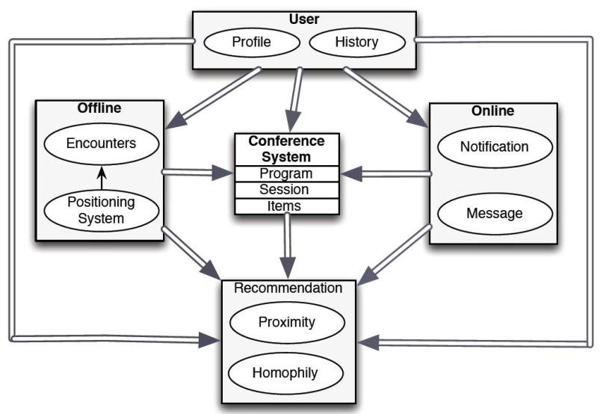
A visual description of the system architecture of our application.

When a user reads another user’s UUID, it means that these two users are within 5 meters of each other for at least 3 minutes, and the app logs this as an encounter between the two users. After developing this application, we worked on a privacy protocol to randomly regenerate UUIDs periodically to ensure user privacy. Finally, we tested our application in a miniature controlled environment.

Results

To determine how effective and accurate our application was, we ran through some test cases during one of our team meetings. 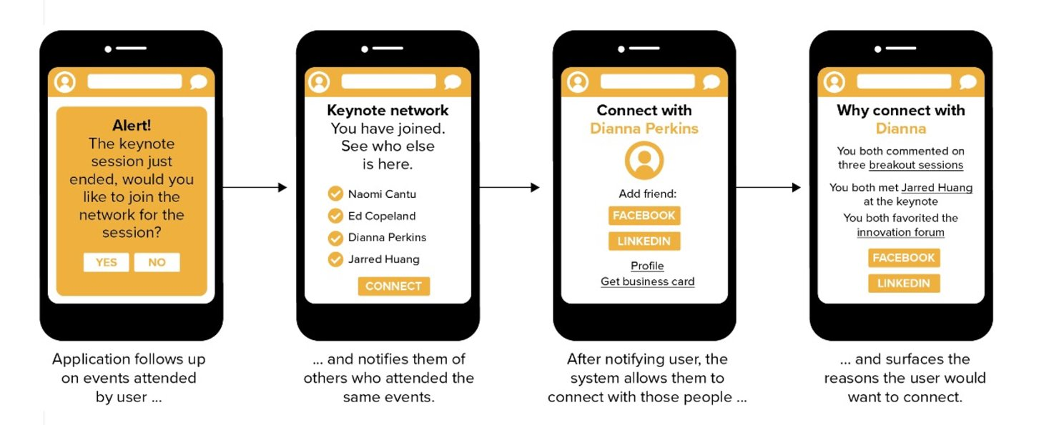
A mockup of the application developed.
Our first test case mimicked a situation where Person 1 and Person 2 were in conversation next to each other and Person 3 was 8 feet away not involved in the conversation. With a Received Signal Strength Indicator (RSSI) parameter of -83, the expected result was an app encounter between Person 1 and Person 2 and 0 encounters involving Person 3. However, we determined the actual result was 1 encounter between Person 1 and Person 3 and 1 encounter between Person 2 and Person 3. While Person 1 picked up on Person 2's Bluetooth signal, Person 2 did not pick up on Person 1 at all. Person 3’s phone did not pick up on anyone. This test case was therefore deemed a failure. Some possible reasons for this include Person 1 made a mistake during testing and may have accidentally turned off their "Bluetooth Scanning" feature which makes their phone’s Bluetooth signal visible to other phones. Additionally, Person 3 had their phone in their bag, reducing Bluetooth efficacy. Our next test case involved a conversation wherein Person 1, 2, and 3 were all in conversation within 5m of one another. This test case was successful. All three phones picked up on the other two involved for correct amounts of time. In this test case, all phones were on the table with the Bluetooth active at all times.

Conclusion

Our results showed that while Bluetooth-based encounter logging holds potential, there are significant challenges that need to be addressed for reliable and accurate performance. The inconsistent results from our test cases highlight the limitations of using RSSI data alone to determine proximity, such as interference from external factors like device placement and user settings. Despite these issues, our approach demonstrated the feasibility of using existing smartphone technology for proximity detection without requiring additional infrastructure.

Discussion & Future Work

Moving forward, improvements can be made by refining the encounter algorithm, incorporating audio data to differentiate between true interactions and mere physical proximity, and further optimizing the indoor positioning system. We hope to make use of deep learning techniques to identify whether users are in specific conference events, such as speaker panels, or simply engaged in discussion with other conference attendees. Additionally, we are looking into the use of LinkedIn APIs to, with permission, collect user data, and further understand the professional relationships a user already has. Furthermore, we are addressing privacy concerns through randomized UUIDs and understanding user behavior through surveys are critical to enhancing user adoption and trust. Future research will focus on overcoming the challenges identified in this study and continue developing more robust and reliable methods for enhancing the networking experience at professional events.

Acknowledgements

We would like to thank Dr. Alvin Chin from Discovery Partners Institute for his guidance with this project.

References

Barnett, N. P., Sokolovsky, A. W., Meisel, M. K., Forkus, S. R., & Jackson, K. M. (2024). Detection of Peer Proximity: Protocol for evaluating functionality and validity of a Bluetooth-based smartphone application (PrePrint). JMIR Research Protocols, 13, e50241. https://doi.org/10.2196/50241
Catarinucci, L., Colella, R., Esposito, A., Tarricone, L., & Zappatore, M. (2011). RFID Sensor-Tags feeding a Context-Aware Rule-Based healthcare monitoring system. Journal of Medical Systems, 36(6), 3435–3449. https://doi.org/10.1007/s10916-011-9794-y
Chin, A., Xu, B., Wang, H., Chang, L., Wang, H., & Zhu, L. (2013). Connecting people through physical proximity and physical resources at a conference. ACM Transactions on Intelligent Systems and Technology, 4(3), 1–21. https://doi.org/10.1145/2483669.2483683
Hogan, K., Macedo, B., Macha, V., Barman, A., & Jiang, X. (2021). Contact Tracing apps: lessons learned on privacy, autonomy, and the need for detailed and thoughtful implementation. JMIR Medical Informatics, 9(7), e27449. https://doi.org/10.2196/27449
Zhao, Q., Wen, H., Lin, Z., Xuan, D., & Shroff, N. (2020). On the Accuracy of Measured Proximity of Bluetooth-Based Contact Tracing Apps. In Springer eBooks (pp. 49–60). https://doi.org/10.1007/978-3-030-63086-7_4

